SVM:

**Feature Eng & FT:**  Since we have kernel in SVM, we don’t need to do Feature eng, but we’ve to choose right kernel RBF.

**Decision Surface:**

* For linear SVM: hyperplane.
* Kernel-SVM: Initially there is non-linear surface, and after kernel transformation there will be linear surface.

**Similarity function/distance function:** we can provide similarity function as kernel.

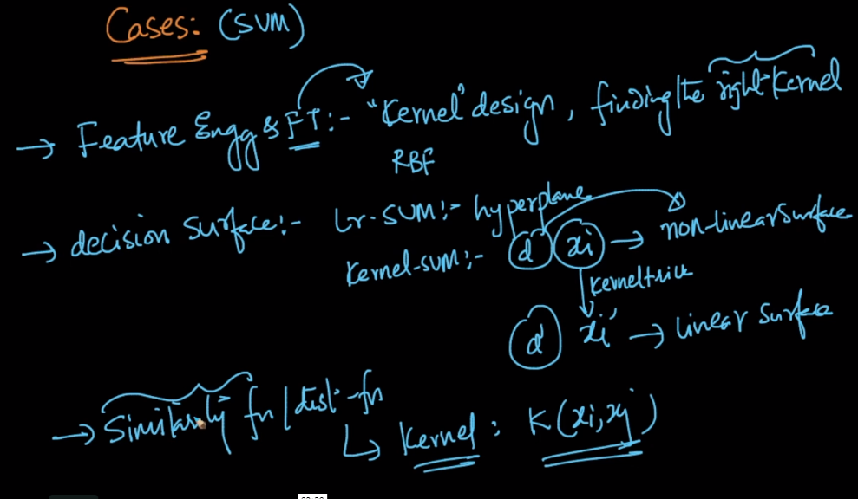

**Interpretability & Feature Importance:** we can’t get Interpretability with krenel SVM, but can get with linear SVM, as we are just creating hyperplane.

We can use forward feature selection for feature importance.

**Outliers:** Typically there is very small impact of outliers on SVM, because eventually we get output using support vectors, so eventually there is SV’s which matters a most.

But RBF kernel is exception, since in RBF we see that with small sigma it’s similar to k-nn with small k, and in such condition k-NN is largely impacted by outliers.

**Bias-Variance tradeoff:**

C maintains the bias variance tradeoff, and for RBF sigma along with C is used to maintain this.

